# Compass - Medicare Part B - Handling the Call - MED B Team Only

General Information

Medicare Part B Coverage

Identifying Medicare B Eligible Beneficiaries

Updating Medicare B Enrollment

Resolution Time

Related Documents

**Description:** This document details the steps needed to handle a call from a Medicare Part B beneficiary.

|  |
| --- |
| General Information |

Medicare Part B (Medical Insurance) helps cover doctors' services and outpatient care. It also covers some other medical services that Part A does not cover, such as some of the services of physical and occupational therapists, and some home health care. Part B helps pay for these covered services and supplies when they are medically necessary.

The Medicare B Team for CVS/Caremark provides beneficiaries’ answers to their Medicare B covered products through Mail Order. Most beneficiaries have a choice to either bill Medicare B or their Prescription plan. A few clients mandate Medicare B to be billed.

Some Mandatory Medicare B clients are listed below (list is not all inclusive). Refer to the CIF to determine if the client is Mandatory Medicare B.

* City of Chicago
* GEHA
* NALC
* State of Florida

**Notes:**

* The Medicare B team is part of CVS/ Caremark and not CMS/1-800-MEDICARE (1-800-633-4227). Questions related to the ‘red/white/blue’ card or durable medical equipment (DME) should be referred to CMS. Refer to Approved Referral Guidelines to Medicare and Social Security for the appropriate guidelines.
* The Medicare Part B team cannot file grievances on behalf of beneficiaries. To file a grievance, the beneficiary must contact 1-800-MEDICARE (1-800-633-4227). For Commercial beneficiaries, to file a complaint, submit the appropriate Support Task.
* Anyone can be eligible for Medicare that has a disability, end stage renal disease or the age of 65 and older. Beneficiaries are charged a premium for Medicare B each month. Medicare Part A does not have a premium. The beneficiary’s deductible must be met before Medicare B will pay 80%.

 Low Income Cost Share (LICS) does **NOT** apply to Medicare B.

The Hours of Operation for the CVS/Caremark Medicare B department are:

* Monday - Friday 7am CST - 6pm CST
* Saturday - 8am CST - 4:30pm CST
* Sunday - Closed

Top of the Document

|  |
| --- |
| Medicare Part B Coverage |

For a list of Medicare B medications, refer to Medicare B Medication List.

**The following are Medicare Part B items NOT handled by CVS Caremark Medicare Part B Team; these are referred to Medicare:**

* Doctor’s visits
* Hospital outpatient care
* Home health care
* Preventative services (**example**: flu shot)

**The following are Medicare Part B Coverage items handled by the CVS Caremark Medicare Part B Team:**

Medications to keep certain illnesses from getting worse, for example:

* Immunosuppressants
* Nebulizer solutions
* Some oral cancer drugs
* Insulin, if provided through a medically necessary insulin pump
  + Can only be billed via a rebill through CVS Caremark Mail Order.
* Others may apply; see Medicare.gov for information.

 A Retail FEP Med B edit is in place. This is only for immunosuppressant and nebulizer medication. The Med B Team will not be the direct contact to receive question calls from the beneficiary or pharmacy. The FEP and Pharmacy Help Desk (PHD) team will take these calls. The Med B team may receive calls from FEP CCRs to confirm Medicare Part B coverage in MARx. Med B at Mail Order is not being offered.

**Items always covered under Med B:**

* DME
* Diabetic supplies (unless specified within a CIF or is a non-mandatory client that normally covers diabetic supplies)

**Note:** CVS Caremark cannot bill Med B for diabetic testing supplies.

**Insulin:**

The only way insulin can be billed to Medicare B is through a rebill. There are some stipulations:

* The beneficiary would need to have a paid claim for the insulin via Medicare D or the commercial account.
* The beneficiary would need to have Medicare Part B per MARx.
* The insulin pump must have been paid for by Medicare.
* The doctor would have had to deem the insulin pump medically necessary.
* There would be a rebill process. This process can take 6-12 weeks for the beneficiary to be reimbursed (sometimes it can take years).
* Payment is not guaranteed as we are not the 3rd party biller to Medicare.

**Diabetic Supplies:**

If the beneficiary would like to utilize Medicare B for receiving their diabetic supplies, they must go to a **retail** pharmacy that accepts Medicare B benefits. Diabetic supplies cannot be filled at Mail Order. Diabetic supplies may also be covered under Commercial Plans. You will need to run a test claim to confirm.

**Prescribing/Ordering a blood glucose monitor and associated accessories:**

**Provider Requirements**

For Medicare coverage of a blood glucose monitor and associated accessories, the provider must provide a valid prescription (order) which must state to the supplier:

1. The item(s) to be dispensed
2. The frequency of testing (“as needed” is not acceptable)
3. The physician’s signature
4. The signature date, and
5. The start date of the order – only required if the start date is different from the signature date.

**For beneficiaries who are insulin-dependent**, Medicare provides coverage for up to 100 test strips and lancets every month, and one lancet device every 6 months.

**For beneficiaries who are non-insulin dependent**, Medicare provides coverage for up to 100 test strips and lancets every 3 months, and one lancet device every 6 months.

**Note:** Medicare allows additional test strips and lancets if deemed medically necessary.

**Items covered due to ESRD and only obtainable at the Dialysis Center:**

* Varies; to confirm, contact Melanie Vann with OmniSYS.
* If a beneficiary is questioning this, they can contact Medicare or OmniSYS directly for verification.

**Example**: Furosemide

**Items covered if prescribed within 48 hours of Chemotherapy. Note: Advise the beneficiary that these items should be filled at retail:**

* Oral cancer drugs & anti-emetics

**Medication covered if beneficiary had a transplant:**

* Prednisone

**Note:** If a beneficiary has not had a transplant, the Prednisone would need to be filled under the beneficiary’s Medicare Part D plan.

**Retail Claims for Medicare Part B:**

The Medicare B Team is unable to view retail claims processed through Medicare B.

* Not all retail pharmacies will process Medicare B claims.
* The beneficiary needs to verify if the pharmacy will bill Medicare B on their behalf and provide their Medicare card to the pharmacist.
* The claim will adjudicate in real time and the beneficiary is expected to pay a 20% co-pay. (Medicare pays 80%.)
* The beneficiary may have secondary coverage through their medical plan that pays 20%. If so, the beneficiary will need to ensure that Medicare has their secondary information on file.

**Note:** If Medicare does not have secondary information on file, a paper claim will need to be submitted to the secondary payer. These claims will not process through CVS/Caremark since they are adjudicated directly to Medicare.

**Specialty Medications:**

* The Specialty pharmacy handles their own Medicare B billing.
* Do **NOT** remove the flag for a specialty medication under any circumstances. The prescription will automatically be removed from our system and processed by the Specialty Pharmacy.
* These calls should be transferred to the Specialty Pharmacy. Refer to Departments & Programs (Phone, Addresses & Hours).

**Medicare B beneficiaries are not eligible for any overrides or reships.**

**Medicare B Deductible Information:**

* Medicare B has a deductible that may change from year to year.
* The Medicare Part B deductible:
  + 2023 - $226.00
  + 2024 - $240.00
  + 2025 - $257.00

 It is important to remember that the beneficiary’s Medicare B deductible does not apply to Medicare Part D.

* The Medicare B team does not have information regarding where beneficiaries are in their deductible phase. Beneficiary questions pertaining to deductibles should be sent to Medicare at 1-800-Medicare.
* Medicare B pays 80% of total cost, beneficiary pays 20% of total cost (unless there is a supplemental insurance, then beneficiary may pay less.)

**Note:** The Medicare B Team is unable to provide any information on supplemental coverage.

Top of the Document

|  |
| --- |
| Identifying Medicare B Eligible Beneficiaries |

A number of indicators and messages are included in **Compass** and the **CIF** to help CCRs identify Medicare Part B eligible beneficiaries.

The tables below list locations and the Medicare B information located within.

**CIF:**

|  |  |
| --- | --- |
| **Location** | **Medicare B Information** |
| **CIF** | The CIF will indicate if the plan is an MAPD Plan.  Refer to the following sections in the CIF for MAPD information:   * Client name description * Need to Know * Plan Design Highlights * Under Maintain Patient Profile   **Note:** If the client is an MAPD plan, calls should NOT be transferred to the Medicare Part B team, as these claims are processed through the plan, and not separately by Medicare B. |

**Compass:**

|  |  |
| --- | --- |
| **Screen** | **Medicare B Information** |
| **Member Snapshot** | The **Member Details** panel will include an **Enrolled - Medicare B** or **Pending** - **Medicare B** indicator when the beneficiary is eligible.  **Notes:**   * These indicators are only visible for **Commercial** clients. * **Assignment of Benefits (AOB)** is a contract signed by a policyholder that gives a third party the ability to file a claim or directly bill an insurer on behalf of the policyholder. * **Enrolled Medicare B: -** indicates that the necessary paperwork (AOB) is on file and the beneficiary is enrolled in Medicare Part B. * **Pending Medicare B: -** may indicate an AOB is still required.   + AOB at **retail** needs to be signed and given to retail pharmacy.   + AOB at **mail** needs to be signed and mailed to address provided in the letter from OmniSYS. * **Self-Identified Medicare B:** - indicates the beneficiary has told CVS Caremark they have Medicare Part B via the mail order form.   **Commercial Account Example:**    **Notes:**   * If the account is for a Medicare Part D client, the CCR will see the existing **Med D** indicator within the **Member Details** panel. * Two indicators can be shown on **Member Snapshot**, under the **Eligibility** field within the **Member Details** panel and under the **Medicare Type** located within the **Additional Eligibility Details** section on the **Eligibility** tab. * If the account **only** has Med B Coverage the **Medicare Type** field will show **Part B Only**. * If the account has **both** Med D and Med B Coverage the **Medicare Type** field will show **Part B** and **Part D.** |
| **Case Details Landing Page** |  |
| **Claims Landing Page** |  |

Top of the Document

|  |
| --- |
| Updating Medicare B Enrollment |

The Medicare B Enrollment sub-tab (Role Codes 2209 & 2212) contains the beneficiary's Med B eligibility information. The Med B subtab can be updated by the Caremark Med B Team and the Medicare B Customer Care Box once changes are verified in MARx.

This subtab is updated so that claims reject and divert correctly within the pharmacy for Medicare B billing, and when claims are incorrectly rejecting & diverting in the pharmacy Med B Billing, such as when a beneficiary is marked Med B Eligible in error.

**The following information is needed to update the Med B Enrollment subtab:**

* Medicare Beneficiary Identifier (MBI)
* Medicare B Effective Date
* Verbal statement from the beneficiary that Medicare B is either Primary or Secondary
* Must have Original Medicare B and not enrolled in an MA/MAPD

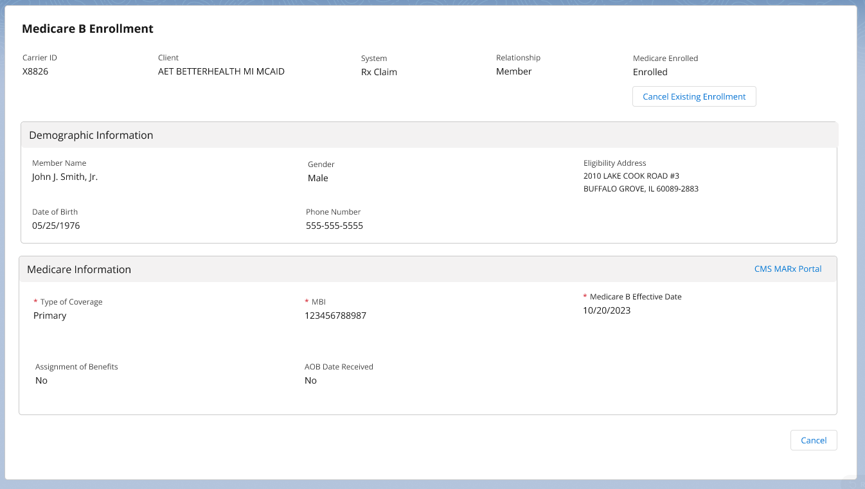

**When is this tab updated?**

* When a beneficiary requests Med B billing (must have original Medicare B)
* If the agent receives a call from the SAT MED B pharmacy
* If the account manager makes the request to update the Medicare B subtab

**To add Med B Eligibility information to Med B enrollment subtab** (aka adding the “Med B Flag”), perform the following:

|  |  |
| --- | --- |
| **Step** | **Action** |
| **1** | Access the beneficiary’s account in Compass. |
| **2** | Navigate to the **Quick Actions** panel from theMember Snapshot Landing Page, and select the **Medicare B Enrollment** hyperlink.  **Result:** The **Medicare B Enrollment** subtab displays. |
| **3** | Determine the member’s Medicare B status. In the **Medicare Enrolled** field, if status shows Eligible, Enrolled, Self-Identified, or Pending, updates can be made.  **Note:** If the status reflects anything other than the ones listed, the Medicare Information section is view only. |
| **4** | Navigate to the **Medicare Information** section, then ask the beneficiary if Med B is primary or secondary.   * Select the **Primary** coverage or **Secondary** coverage radio button. |
| **5** | Enter the Medicare Claim Number (MBI) in the “Medicare ID” field. |
| **6** | Enter the Medicare B effective date in the **Effective Date** field. |
| **7** | Select **Save** in the bottom right corner.  **Result:** “**Medicare B enrollment submitted successfully**” message displays.  **Notes:**   * Select the **Cancel** button to discard any changes. The information will not be saved or submitted. * If Compass is unable to save enrollment information, an error message displays on the Medicare B enrollment screen.   The **Medicare Enrolled** field at the top will then show “PENDING” or “Always Eligible” if “Primary Coverage” was selected and will show “PENDING MSP” if “Secondary Coverage” was selected. |
| **8** | Document in Order Level Alerts who requested the flag update and the reason for the update. |

**Note:** If the Medicare B box is greyed out, the client is a mandatory Medicare B client or it is an MAPD client.

**When is the information removed from this tab?**

* The eligibility information should be removed if the beneficiary does not want to use Med B.
* If it is causing unnecessary rejections & diverts, so long as the beneficiary confirms they don’t want to use Med B. **Note:** A statement from the beneficiary such as: “I don’t have Med B” is sufficient.
* If the beneficiary does not have Original Medicare B, either due to:
  + Being enrolled in an MA/MAPD **OR**
  + The beneficiary is not eligible for Medicare B. (Verified through MARx).
* Beneficiary does NOT request Med B billing and would like to “opt out” of the Medicare B billing process.

**Cancel Existing Medicare B Enrollment** (AKA Removing the “Med B Flag”), perform the following:

|  |  |  |
| --- | --- | --- |
| **Step** | **Action** | |
| **1** | Access the beneficiary’s account in Compass. | |
| **2** | Medicare B Enrollment subtab is accessed through the Member Snapshot Quick Actions Panel via Medicare B Enrollment hyperlink. | |
| **3** | If status is Enrolled, Self-Identified, or Pending, the Cancel Existing Enrollment button will be enabled.  **Note:** If status is **not** Enrolled, Self-Identified, or Pending, Cancel Existing Enrollment button will be disabled. | |
| **4** | In the Medicare information section, select the “Secondary Coverage” radio button & check “Working Spouse”. | |
| **5** | Select the “Save” button at the bottom right of the screen. | |
| **6** | Select the **Cancel Existing Enrollment** button on the top right of the screen, in the Medicare B Enrollment subtab.  **Result:** Pop-up message states, "Are you sure you want to cancel this member's existing enrollment?" with the option to select yes or no. | |
| **If…** | **Then…** |
| Yes | “Existing Medicare B enrollment cancelled successfully” displays on the Medicare B Enrollment subtab. |
| No | The pop-up message closes; user is returned to Med B Enrollment subtab. |
| **7** | The “Medicare Enrolled” field at the top will then show “NOT ELIGIBLE”. | |
| **8** | Document in Order Level Alerts who requested the flag update, and the reason for the update. | |
| **9** | Notate in Order Level Alert that the beneficiary wants to “opt out” of Medicare B enrollment billing. | |
| **10** | Indicate if the prescription will be filled under the plan now that the Medicare B flag has been removed. | |
| **11** | Warm transfer the call to the Commercial number listed in the CIF. | |

Top of the Document

|  |
| --- |
| Resolution Time |

Information = Immediate

Forms = Up to 7 business days

Transfer to OmniSYS = Immediate

Refill Requests = Varies

Top of the Document

|  |
| --- |
| Related Documents |

**Parent SOP:** CALL-0048: [Medicare Part D Customer Care Call Center Requirements-CVS Caremark Part D Services, L.L.C.](https://policy.corp.cvscaremark.com/pnp/faces/SecureDocRenderer?documentId=CALL-0048&uid=pnpdev1)

**Abbreviations/Definitions:** Abbreviations / Definitions

Top of the Document

Not To Be Reproduced Or Disclosed to Others Without Prior Written Approval

**ELECTRONIC DATA = OFFICIAL VERSION / PAPER COPY = INFORMATIONAL ONLY**